- Open YouTube and search for 'How to make Dalgona coffee'. Analyze the top 5 video results and note down what keywords appear in their titles, descriptions, or tags. List the most common keywords you find.
Video | Keywords found in title/description
Dalgona Coffee Recipe – How To Make Dalgona Coffee – Yum Curry | Dalgona Coffee, Coffee Recipe, How To Make, Homemade, Without Mixer, Cold Coffee (YouTube)
DALGONA COFFEE – How to make dalgona coffee at home – Dritan Alsela | Dalgona Coffee, How to Make, At Home, Easy, Instant Coffee, Sugar, Milk (YouTube)
Easy Dalgona Coffee Without Mixer (3 Minute 4 Ingredients At Home) – Davao Tech Reviews | Dalgona Coffee, Without Mixer, Easy, At Home, 4 Ingredients, Frothy Coffee, Whipped Coffee, Cloud Coffee (YouTube)

- Go to Amazon.in and search for 'wireless earbuds'. Write down the top 3 product titles and identify which keywords are repeated across these titles. Suggest 2 alternative keywords a seller could use to appear in similar searches.
Product title | Important keywords
OnePlus Nord Buds 3 Truly Wireless Bluetooth in Ear Earbuds | Truly Wireless, Bluetooth, Earbuds, Noise Cancellation, Fast Charging
boAt Airdopes 141 Elite ANC Bluetooth Earbuds | Bluetooth, Earbuds, TWS, Wireless Earphones, ANC, Fast Charge
realme Buds T310 True Wireless in-Ear Earbuds | True Wireless, Earbuds, ANC, Bluetooth, Fast Charging

The most repeated keywords are:
- Earbuds
- Wireless / True Wireless
- Bluetooth
- Fast Charging
- ANC / Noise Cancellation

2 Alternative Keywords for a Seller
A seller could also target:
- Bluetooth TWS earbuds
- Wireless earbuds with mic

- Use your phone’s Google Lens or Pinterest Lens to visually search for any item in your room (e.g., a sneaker, book, or snack). Take a screenshot of the visual search results and describe how the search engine interprets your image to suggest products or information.
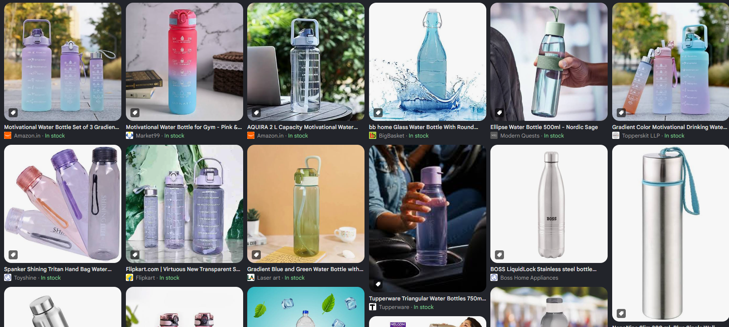

- Try a voice search on your phone using Google Assistant or Siri for 'best pizza near me'. Note the exact phrase you spoke and compare the results with a typed search for the same query. List any differences in the results or the way information is displayed.<br><br><em><strong>Hint:</strong> Pay attention to featured snippets, map packs, or direct answers.</em>
Voice Search | Typed Search
Google understands the spoken phrase “best pizza near me” and uses your location. | You type “best pizza near me” manually.
Usually focuses strongly on nearby businesses and direct answers. | Usually shows a Google Maps/local 3-pack, followed by organic results.
May give a spoken answer such as a nearby pizza restaurant. | Shows ratings, reviews, distance, opening hours, directions, photos, etc.
Results can be more conversational. | Results are more detailed and visual.

- Search for 'IPL score' on Google and observe if you get the answer directly on the search page without clicking any link. Explain what a Zero-click search is, and give 2 more examples of queries that show Zero-click results.

Zero-Click Search – Easy Explanation
When we search “IPL score” on Google, Google can show the match score directly on the search page. We don't need to open any website.
Zero-click search means getting the answer directly on Google without clicking a website.
2 examples:
- “Capital of India” → New Delhi appears directly.
- “100 USD in INR” → Google shows the conversion directly.

